

**HTML5 Training Plan**

Assignment

CapTech Ventures, Inc.

1419 West Main Street

Richmond, VA 23220

804.355.0511

FAX 804.355.4220

Table of Contents

Assignment 3

Assignment Objectives 3

Recommended Approach 4

Backbone.js Single Page App 4

Deliverables 4

Visual Design 4

Home Page 5

Content Page 6

Style Guide 6

API Reference 8

Retrieve All Articles 8

Retrieve Articles By Category 11

Retrieve An Article By Id 13

Retrieve All Banner Messages 14

Retrieve List Of Categories 15

Resources 16

# Assignment

This assignment is designed to allow the developer to become familiar with building a modern web interface using the features of HTML5 and CSS3. Additional goals are to allow the developer to become familiar with client-side JavaScript and implementation of a provided visual design. This assignment can be completed using a variety of tools, frameworks and web servers.

The application must do the following:

* Display a **Home Page** with a list of featured news article headlines and snippets.
* When the user clicks on a category they are redirected to a **Content Page** displaying all content of that category.
* When the user clicks on the Banner’s call to action the Banner’s height is doubled with a CSS3 transition.
* Specify Appropriate HTML5 doctype
* Utilize HTML5 Semantic elements <section>, <article>, <nav>, <header>, <footer> and <aside>.
* Retrieve the news articles from the provided RESTful JSON Service.
* Integrate the specified google webfont.
* Follow the provided Visual Design.
  + Width is 960
  + Font heights and line heights are in PhotoShop Pts
  + Elements with styles specified for first instances should be via CSS3 pseudoclasses
* Integrate Font Awesome Icons.
* The Application must be a single HTML page and fetch all data via JavaScript.

# Assignment Objectives

When completed the student should have an understanding of the following concepts:

* Semantic HTML5 Elements
* Single Page Web Apps
* AJAX
* JSON
* WebFonts
* Featured CSS3 functionality

# Recommended Approach

## Backbone.js Single Page App

* Web resources
  + JQuery
  + Backbonejs
  + Underscorejs
* Required Tools
  + Web Browser
  + Chrome Devtools, Safari Web Inspector or Firebug
  + Text Editor
  + Web Server
* CapTech Resources
  + Josh Stickles
  + Reid Braswell

# Deliverables

An application that meets the above requirements displaying properly on Chrome, Firefox or Safari is required for completion of this assignment.

# Visual Design

The following is the visual design for the application that the developer will be building. Additionally the PSD for the visual design is provided in the zip file for this assignment. Please note that the top sections, search and user icons are non-functional.

## Home Page

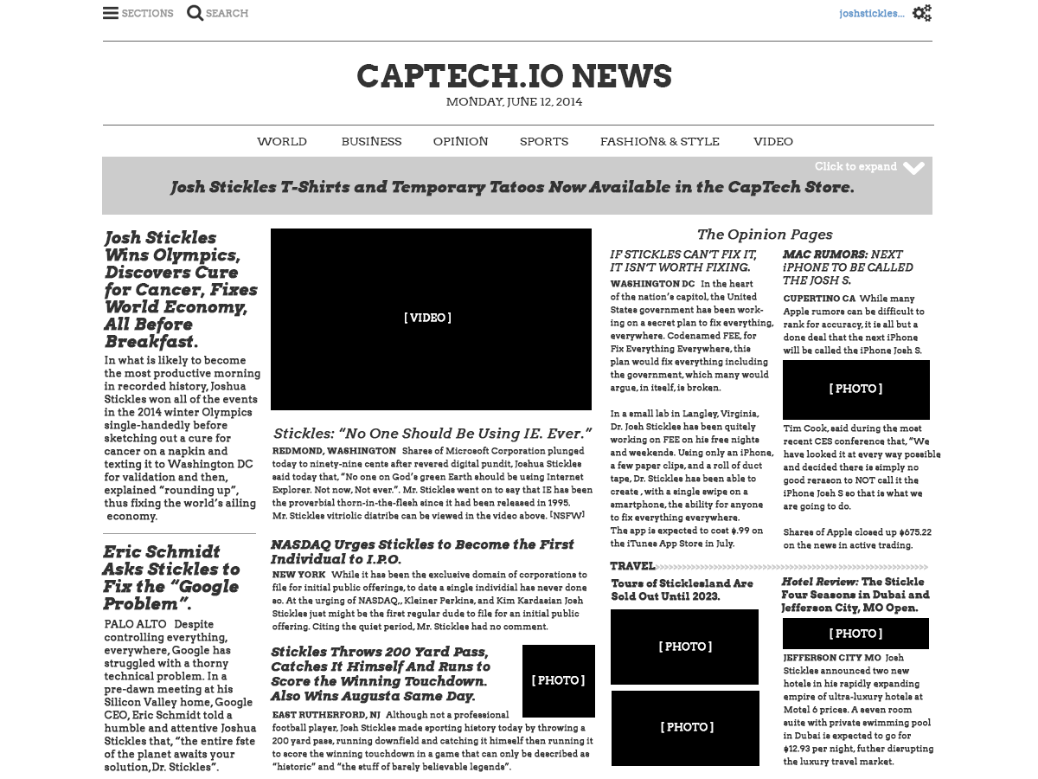

## Content Page

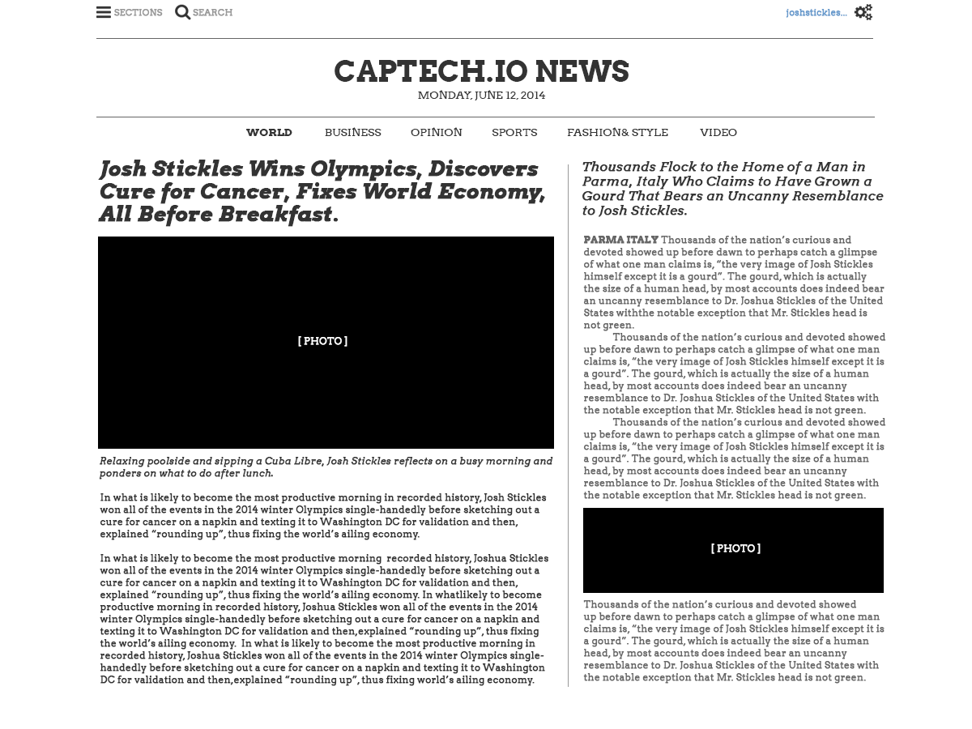

# Style Guide

* Header
  + All Icons
    - Font Awesome
  + Top Nav
    - Arvo Regular 9pt, 3cccccc
  + Title
    - Arvo Bold 36 pt, #333333
  + Date
    - Arvo regular 14 pt, #333333
  + Categories
    - Arvo regular 14 pt, #333333
* Home Page
  + Banner
    - Content
      * Arvo Bold Italic 18 pt, #333333
    - Call to Action
      * Arvo regular 12 pt
  + Aside
    - Article Title
      * Arvo Bold Italic, 19pt/20, #333333
    - Article Snippet
      * Arvo Regular 12pt/15, #333333
  + Main Section
    - Article Title – First
      * Arvo Italic 16pt/20, #333333
    - Article Title
      * Arvo Bold Italic 16pt/20, #333333
    - Article Snippet
      * Arvo 10pt/15, #333333
  + Opinion Section
    - Title
      * Arvo Italic 16pt #333333
    - Article Title – First
      * Arvo Italic 12pt/15, #333333
    - Article Title
      * Arvo Bold & Arvo Italic 12pt/15, #333333
    - Article Snippet
      * Arvo 10pt/15, #333333
  + Travel Section
    - Title
      * Arvo Bold 12pt, #333333, #cccccc
    - Article Title – First
      * Arvo Bold 12pt/15, #333333
    - Article Title
      * Arvo Bold Italic & Arvo Bold 12pt/15, #333333
    - Article Snippet
      * Arvo 10pt/15, #333333
* Content Page
  + Main Section
    - Article Title
      * Arvo Bold Italic 26pt/28, #333333
    - Article Multimedia Caption
      * Arvo Italic 10pt/15, #333333
    - Article Content
      * Arvo Regular 10pt/15, #333333
  + Related Content Section
    - Article Title
      * Arvo Italic 16pt/18, #666666
    - Article Content
      * Arvo Bold & Arvo Regular 12pt/15, #666666

# API Reference

The following is a definition of the HTML5News service API to be used during this assignment. In URL definitions values within [brackets] represent variables. Please note that not all news articles have pre-written stories and may contain Lorem Ipsum.

## Retrieve Featured Articles

#### URL: http://html5news.herokuapp.com/articles/featured

#### HTTP Method: GET

#### Response:

This service returns a JSON object representing the featured news of the day. This object has different properties that are arrays of articles from featured areas of the news service.

#### Sample Response:

{

aside: [

{

"id": 1,

"headLine": "Josh Stickles Wins Olympics, Discovers Cure for Cancer, Fixes World Economy, All Before Breakfast.",

"snippet": "In what is likely to become the most productive morning in recorded history, Joshua Stickles won all of the events in the 2014 winter Olympics single-handedly before sketching out a cure for cancer on a napkin and texting it to Washington DC for validation and then, explained “rounding up”, thus fixing the world’s ailing economy.",

"fullStory": "Relaxing poolside and sipping a Cuba Libre, Josh Stickles reflects on a busy morning and ponders on what to do after lunch. In what is likely to become the most productive morning in recorded history, Josh Stickles won all of the events in the 2014 winter Olympics single-handedly before sketching out a cure for cancer on a napkin and texting it to Washington DC for validation and then, explained “rounding up”, thus fixing the world’s ailing economy. In what is likely to become the most productive morning recorded history, Joshua Stickles won all of the events in the 2014 winter Olympics single-handedly before sketching out a cure for cancer on a napkin and texting it to Washington DC for validation and then, explained “rounding up”, thus fixing the world’s ailing economy. In what likely to become productive morning in recorded history, Joshua Stickles won all of the events in the 2014 winter Olympics single-handedly before sketching out a cure for cancer on a napkin and texting it to Washington DC for validation and then, explained “rounding up”, thus fixing the world’s ailing economy. In what is likely to become the most productive morning in recorded history, Joshua Stickles won all of the events in the 2014 winter Olympics single-handedly before sketching out a cure for cancer on a napkin and texting it to Washington DC for validation and then, explained “rounding up”, thus fixing world’s ailing economy.",

"location": "Sochi",

"nsfw": false,

"category": 1,

"relatedArticleIds": [

10

]

}, ….

],

main: […..],

opinion: […..],

travel: […..]

}

## Retrieve All Articles

#### URL: <http://html5news.herokuapp.com/articles/all>

#### HTTP Method: GET

#### Response:

This service returns an array of JSON objects representing news articles.

#### Sample Response:

[

{

"id": 1,

"headLine": "Josh Stickles Wins Olympics, Discovers Cure for Cancer, Fixes World Economy, All Before Breakfast.",

"snippet": "In what is likely to become the most productive morning in recorded history, Joshua Stickles won all of the events in the 2014 winter Olympics single-handedly before sketching out a cure for cancer on a napkin and texting it to Washington DC for validation and then, explained “rounding up”, thus fixing the world’s ailing economy.",

"fullStory": "Relaxing poolside and sipping a Cuba Libre, Josh Stickles reflects on a busy morning and ponders on what to do after lunch. In what is likely to become the most productive morning in recorded history, Josh Stickles won all of the events in the 2014 winter Olympics single-handedly before sketching out a cure for cancer on a napkin and texting it to Washington DC for validation and then, explained “rounding up”, thus fixing the world’s ailing economy. In what is likely to become the most productive morning recorded history, Joshua Stickles won all of the events in the 2014 winter Olympics single-handedly before sketching out a cure for cancer on a napkin and texting it to Washington DC for validation and then, explained “rounding up”, thus fixing the world’s ailing economy. In what likely to become productive morning in recorded history, Joshua Stickles won all of the events in the 2014 winter Olympics single-handedly before sketching out a cure for cancer on a napkin and texting it to Washington DC for validation and then, explained “rounding up”, thus fixing the world’s ailing economy. In what is likely to become the most productive morning in recorded history, Joshua Stickles won all of the events in the 2014 winter Olympics single-handedly before sketching out a cure for cancer on a napkin and texting it to Washington DC for validation and then, explained “rounding up”, thus fixing world’s ailing economy.",

"location": "Sochi",

"nsfw": false,

"category": 1,

"relatedArticleIds": [

10

]

},

{

"id": 2,

"headLine": "Eric Schmidt Asks Stickles to Fix the “Google Problem”.",

"snippet": "Despite controlling everything, everywhere, Google has struggled with a thorny technical problem. In a pre-dawn meeting at his Silicon Valley home, Google CEO, Eric Schmidt told a humble and attentive Joshua Stickles that, “the entire fate of the planet awaits your solution, Dr. Stickles”.",

"fullStory": "Direct trade selfies artisan locavore. Portland hoodie McSweeney's deep v slow-carb literally. Godard next level blog, street art American Apparel Austin meh kale chips you probably haven't heard of them pug. Umami direct trade 8-bit farm-to-table. Pickled fashion axe normcore, Intelligentsia you probably haven't heard of them cred cornhole four loko Odd Future gastropub yr sartorial sustainable. Pour-over kogi Helvetica next level. Polaroid Schlitz Banksy plaid occupy mustache. Paleo cray sriracha letterpress, raw denim craft beer Schlitz tousled cliche. Ennui retro mumblecore, Intelligentsia pug semiotics meggings. Quinoa XOXO Neutra lo-fi. Blog chia Etsy, Banksy try-hard Helvetica ennui. Church-key distillery meggings street art, roof party single-origin coffee freegan slow-carb. Blue Bottle tofu Odd Future, put a bird on it art party banh mi ethical vegan Austin banjo Pitchfork. Letterpress art party hashtag plaid, banjo yr bespoke lo-fi cornhole Terry Richardson. Asymmetrical Vice freegan banh mi. Chia actually Williamsburg four loko, plaid semiotics drinking vinegar occupy. Kitsch stumptown banjo Helvetica. Scenester High Life shabby chic Portland. Dreamcatcher pickled food truck, locavore umami banjo ethnic seitan Truffaut iPhone vinyl squid swag. Authentic irony keytar Shoreditch sartorial. Art party VHS Terry Richardson fashion axe, ethnic cornhole stumptown. Bicycle rights sustainable biodiesel, polaroid next level cornhole meggings occupy photo booth Odd Future. Aesthetic pop-up 8-bit mumblecore, Thundercats irony butcher shabby chic literally you probably haven't heard of them. Flannel roof party 90's direct trade tousled, flexitarian yr craft beer meggings distillery hoodie. Banh mi narwhal direct trade, photo booth art party lomo meggings street art asymmetrical vegan. Vegan tousled craft beer fanny pack, occupy paleo American Apparel Thundercats salvia flexitarian roof party stumptown quinoa Marfa ethnic. PBR ugh pour-over, tattooed cardigan bicycle rights banjo beard paleo flannel. Synth squid photo booth typewriter lo-fi, irony authentic drinking vinegar Etsy pop-up mumblecore.",

"location": "Palo Alto",

"nsfw": false,

"category": 2,

"relatedArticleIds": [

3,

4

]

}]

## Retrieve Articles By Category

#### URL: <http://html5news.herokuapp.com/category/[id>]

#### HTTP Method: GET

#### Response:

This service returns an object with two properties one representing the featured article for the category and the other the aside article for the category.

#### Sample Response:

{

main: {

"id": 6,

"headLine": "IF STICKLES CAN’T FIX IT, IT ISN’T WORTH FIXING.",

"snippet": "In the heart of the nation’s capitol, the United States government has been working on a secret plan to fix everything, everywhere. Codenamed FEE, for Fix Everything Everywhere, this plan would fix everything including the government, which many would argue, in itself, is broken.",

"fullStory": "In the heart of the nation’s capitol, the United States government has been working on a secret plan to fix everything, everywhere. Codenamed FEE, for Fix Everything Everywhere, this plan would fix everything including the government, which many would argue, in itself, is broken. In a small lab in Langley, Virginia, Dr. Josh Stickles has been quietly working on FEE on his free nights and weekends. Using only an iPhone, a few paper clips, and a roll of duct tape, Dr. Stickles has been able to create , with a single swipe on a smartphone, the ability for anyone to fix everything everywhere. The app is expected to cost $.99 on the iTunes App Store in July.",

"location": "Washington, DC",

"nsfw": false,

"category": 6,

"relatedArticleIds": [

7,

8

]

},

aside: {

"id": 7,

"headLine": "MAC RUMORS: NEXT iPHONE TO BE CALLED THE JOSH S.",

"snippet": "While many Apple rumors can be difficult to rank for accuracy, it is all but a done deal that the next iPhone will be called the iPhone Josh S. Tim Cook, said during the most recent CES conference that, “We have looked it at every way possible and decided there is simply no good reason to NOT call it the iPhone Josh S so that is what we are going to do.",

"fullStory": "While many Apple rumors can be difficult to rank for accuracy, it is all but a done deal that the next iPhone will be called the iPhone Josh S. Tim Cook, said during the most recent CES conference that, “We have looked it at every way possible and decided there is simply no good reason to NOT call it the iPhone Josh S so that is what we are going to do. Shares of Apple closed up $675.22 on the news in active trading.",

"location": "Cupertino, CA",

"nsfw": false,

"category": 6,

"relatedArticleIds": [

8,

9

]

}

}

## Retrieve An Article By Id

#### URL: <http://html5news.herokuapp.com/articles/[id>]

#### HTTP Method: GET

#### Response:

This service returns a JSON object representing a New article that corresponds to the id provided.

#### Sample Response:

{

"id": 1,

"headLine": "Josh Stickles Wins Olympics, Discovers Cure for Cancer, Fixes World Economy, All Before Breakfast.",

"snippet": "In what is likely to become the most productive morning in recorded history, Joshua Stickles won all of the events in the 2014 winter Olympics single-handedly before sketching out a cure for cancer on a napkin and texting it to Washington DC for validation and then, explained “rounding up”, thus fixing the world’s ailing economy.",

"fullStory": "Relaxing poolside and sipping a Cuba Libre, Josh Stickles reflects on a busy morning and ponders on what to do after lunch. In what is likely to become the most productive morning in recorded history, Josh Stickles won all of the events in the 2014 winter Olympics single-handedly before sketching out a cure for cancer on a napkin and texting it to Washington DC for validation and then, explained “rounding up”, thus fixing the world’s ailing economy. In what is likely to become the most productive morning recorded history, Joshua Stickles won all of the events in the 2014 winter Olympics single-handedly before sketching out a cure for cancer on a napkin and texting it to Washington DC for validation and then, explained “rounding up”, thus fixing the world’s ailing economy. In what likely to become productive morning in recorded history, Joshua Stickles won all of the events in the 2014 winter Olympics single-handedly before sketching out a cure for cancer on a napkin and texting it to Washington DC for validation and then, explained “rounding up”, thus fixing the world’s ailing economy. In what is likely to become the most productive morning in recorded history, Joshua Stickles won all of the events in the 2014 winter Olympics single-handedly before sketching out a cure for cancer on a napkin and texting it to Washington DC for validation and then, explained “rounding up”, thus fixing world’s ailing economy.",

"location": "Sochi",

"nsfw": false,

"category": 1,

"relatedArticleIds": [

10

]

}

## Retrieve All Banner Messages

#### URL: <http://html5news.herokuapp.com/banners>

#### HTTP Method: GET

#### Response:

This service returns an array of JSON objects representing the banner adds at the top of the page.

#### Sample Response:

[

{

"id": 1,

"message": "Josh Stickles T-Shirts and Temporary Tatoos Now Available in the CapTech Store."

},

{

"id": 2,

"message": "Available For a Limited Time Only, $19.99 + s/h."

}

]

## Retrieve List Of Categories

#### URL: <http://html5news.herokuapp.com/articles/categories>

#### HTTP Method: GET

#### Response:

This service returns an array of JSON object representing the categories of News articles.

#### Sample Response:

[

{

"id": 1,

"shortName": "world",

"displayName": "WORLD"

},

{

"id": 2,

"shortName": "business",

"displayName": "BUSINESS"

}]

# Resources

The following is a list of links that provide tutorials and guides for the frameworks and tools in the Recommended Approach section.

* MDN HTML5 Guides: <https://developer.mozilla.org/en-US/docs/Web/Guide/HTML/HTML5>
* HTML5 Elements: <http://blog.teamtreehouse.com/use-html5-sectioning-elements>
* HTML5 Fundamentals: <http://www.pluralsight.com/training/Courses/TableOfContents/html5-fundamentals>
* HTML5 Forms: <http://www.pluralsight.com/training/Courses/TableOfContents/html-forms>
* HTML5 Advanced Topics: <http://www.pluralsight.com/training/Courses/TableOfContents/html5-advanced>
* CSS3: <http://www.pluralsight.com/training/Courses/TableOfContents/css3>
* Using HTML5 and CSS3: <http://www.pluralsight.com/training/Courses/TableOfContents/html5css3-upgrade>
* jQuery Fundamentals: <http://www.pluralsight.com/training/Courses/TableOfContents/jquery-fundamentals>
* jQuery Advanced Topics: <http://www.pluralsight.com/training/Courses/TableOfContents/jquery-adv>
* Font Awesome: <http://fortawesome.github.io/Font-Awesome/>
* Arvo Google WebFont: <http://www.google.com/fonts/specimen/Arvo>
* jQuery: <http://jquery.com/>
* Backbonejs: <http://backbonejs.org/>
* Underscorejs: <http://underscorejs.org/>